Computer Language Coding Concepts

System Interface of a Related Item
When you open up the system interface for a Related Item, you get to see the system commands that apply to Related Items. Aspects, that apply to a Related Item are:

- Reference
- Object
- Existance
- Class
- Name

The Reference Aspect in the System Interface
The Reference aspect is controlled through only one command:

Reference Get

The Reference aspect is placed inside a triangle, that wraps together the members to control the Reference aspect:

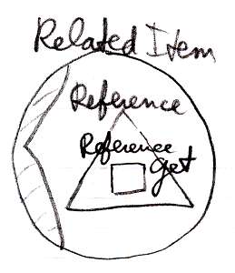

The Object Aspect in the System Interface
The Object aspect of a Related Item is controlled through several commands:

Object Get
Object Set
Use Reference As Object

The commands are placed inside a triangle, that wraps together the members of the Object aspect:

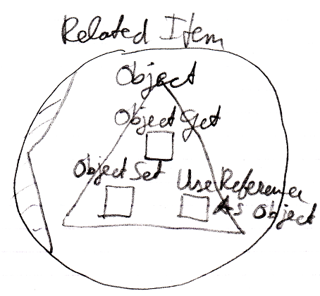

The Existance Aspect in the System Interface
The Existance aspect is controlled through two commands and an attribute:

New
Annul
Is Something

The members are placed inside a triangle, that wraps together the members of the Existance aspect:

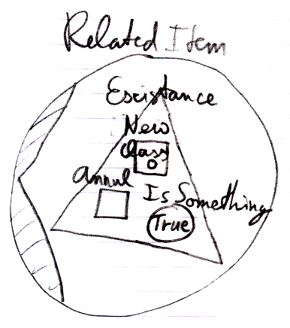

The Reference-Class Aspect in the System Interface
The Class aspect has five system commands, but only three of them apply to Related Items:

Class Set
Reference-Class Get
Use Reference As Class

The commands are placed inside a triangle, that wraps together the members of the Class aspect:

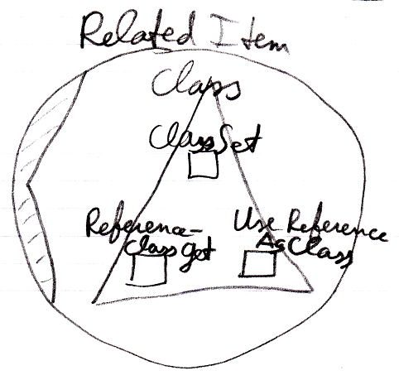

The Name Aspect in the System Interface
The Name aspect is controlled through two commands:

Name Get
Name Set

The commands are placed inside a triangle, that wraps together the members of the Name aspect:

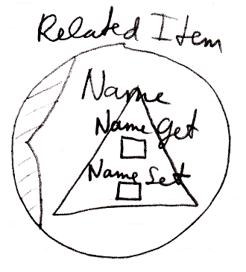

The Full System Interface for Related Item
The full system interface of a Related Item looks like this:

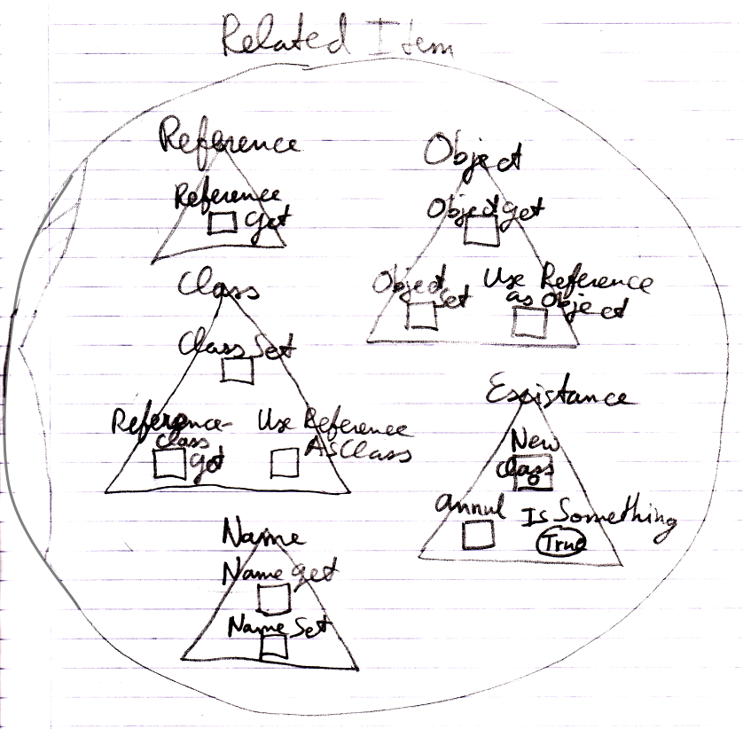

Author & Copyright: Jan-Joost van Zon Date: August 25, 2009 – August 26, 2009 Location: Oosterhout, The Netherlands Status: Finished

